

S.B. JAIN INSTITUTE OF TECHNOLOGY MANAGEMENT & RESEARCH, NAGPUR

Practical 03

Aim: Automate student marksheet generation, system information display, Fibonacci and prime number generation, and file management operations using shell scripts to enhance computational efficiency and user interaction.

Name: Atharva Motikar
USN:CM25D002
Semester / Year: IV/II Academic Session: Date of Performance: Date of Submission:

- Aim: Automate student marksheet generation, system information display, Fibonacci and prime number generation, and file management operations using shell scripts to enhance computational efficiency and user interaction.

- Tasks to be done in this Practical.
- Write a shell script to generate mark- sheet of a student. Take 3 subjects, calculate and display total marks, percentage and Class obtained by the student.
- Write a menu driven shell script which will print the following menu and execute the given task.
  - Display calendar of current month.
  - Display today’s date and time.
  - Display usernames those are currently logged in the system.
  - Display your terminal number
- Write a shell script which will generate first n Fibonacci numbers like: 1, 1, 2, 3, 5, 13
- Write a shell script which will accept a number b and display first n prime numbers as output.
- Write menu driven program for file handling activity
  - Creation of file.
  - Write content in the file.
  - Upend file content.
  - Delete file content

- Objectives:
  - Automate marksheet generation with total, percentage, and class classification.
  - Develop menu-driven scripts for system information and file operations.
  - Generate Fibonacci and prime numbers for user-defined inputs.


- Requirements:
- Hardware Requirements:
- Processor: Minimum 1 GHz
- RAM: 512 MB or higher
- Storage: 100 MB free space
  - Software Requirements:
- Operating System: Linux/Unix-based
- Shell: Bash 4.0 or higher
- Text Editor: Nano, Vim, or any preferred editor

- Theory:
Shell scripting is a powerful way to automate repetitive tasks and manage system operations efficiently. It allows users to write programs using shell commands and scripting constructs. Shell scripts are interpreted line-by-line by a shell interpreter, making them ideal for administrative tasks, file management, and system automation. This practical encompasses a variety of real-world scenarios that demonstrate the utility of shell scripting for computing tasks and resource management.
- Marksheet Generation
This script takes input marks for three subjects, calculates the total marks, percentage, and determines the class of the student based on predefined conditions. Conditional statements (if-else) are used to classify the performance into distinction, first class, second class, or fail. This exercise emphasizes the use of arithmetic operations and decision-making constructs.
Key concepts include:
  - Reading user input using read
  - Arithmetic operations with $((expression))
  - Conditional statements for decision-making
- Menu-Driven Script for System Information
Menu-driven scripts enhance user interaction by presenting a list of options for performing different tasks. In this practical, options are provided to display the calendar of the current month, the current date and time, logged-in users, and the terminal number. The script utilizes looping constructs (while) and case statements for structured flow control.

Commands used:
  - cal for displaying the calendar
  - date for showing current date and time
  - who to list logged-in users
  - tty to identify the terminal
- Fibonacci Number Generation
Fibonacci numbers are a sequence where each term is the sum of the two preceding ones. The script uses iterative constructs (for loop) to generate n terms based on user input. This practical illustrates the use of loop control and variable swapping to generate series data efficiently.

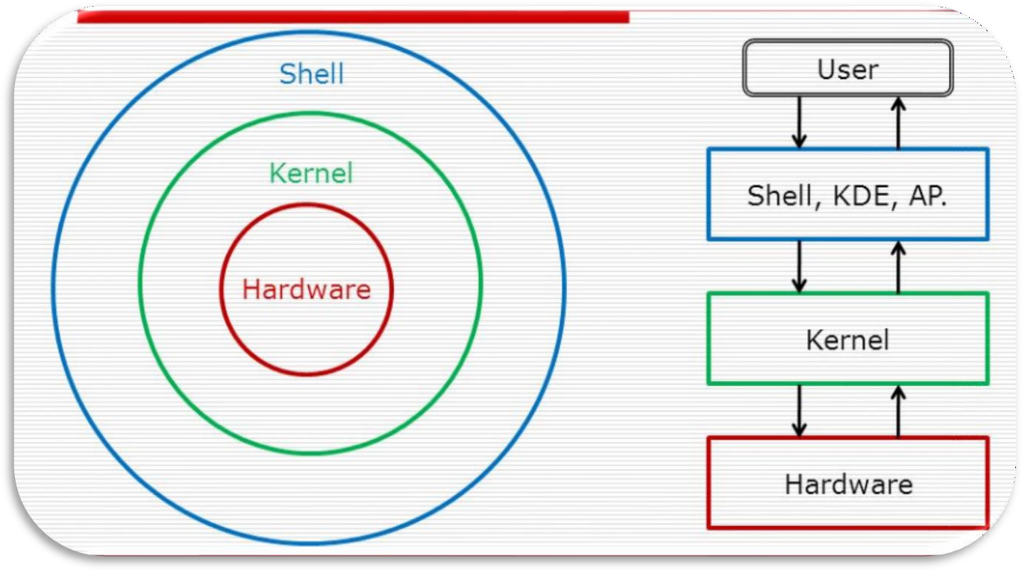
- Prime Number Display
This script accepts an integer n and outputs the first n prime numbers. A nested loop checks divisibility to determine if a number is prime. The practical demonstrates logic building for number-theoretic operations using loops and conditionals.
- Menu-Driven File Management
The file handling script enables users to create, write, append, and delete file content. The case construct manages different file operations.
Commands include:
  - touch to create files
  - cat for writing and appending content
  - rm for deleting files
This exercise emphasizes text manipulation, input handling, and file control mechanisms in Unix-like environments.

Diagrammatical View of Shell

- CODES
- Write a shell script to generate mark- sheet of a student. Take 3 subjects, calculate and display total marks, percentage and Class obtained by the student.

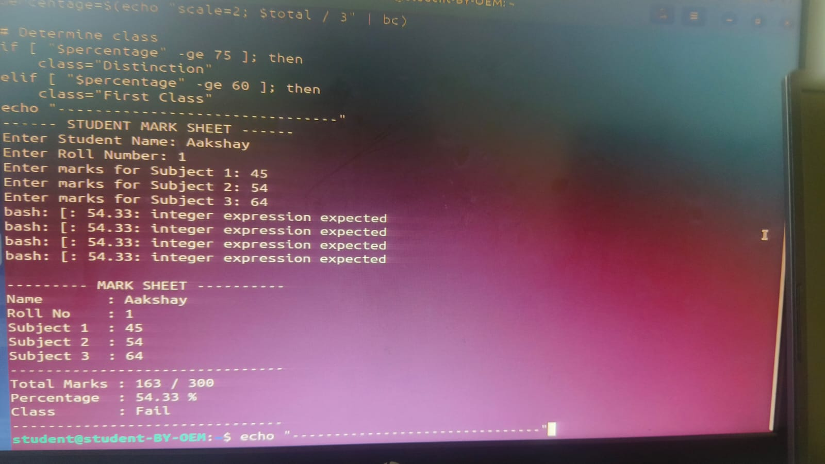
Output 1:

- Write a menu driven shell script which will print the following menu and execute the given task.
  - Display calendar of current month.
  - Display today’s date and time.
  - Display usernames those are currently logged in the system.
  - Display your terminal number
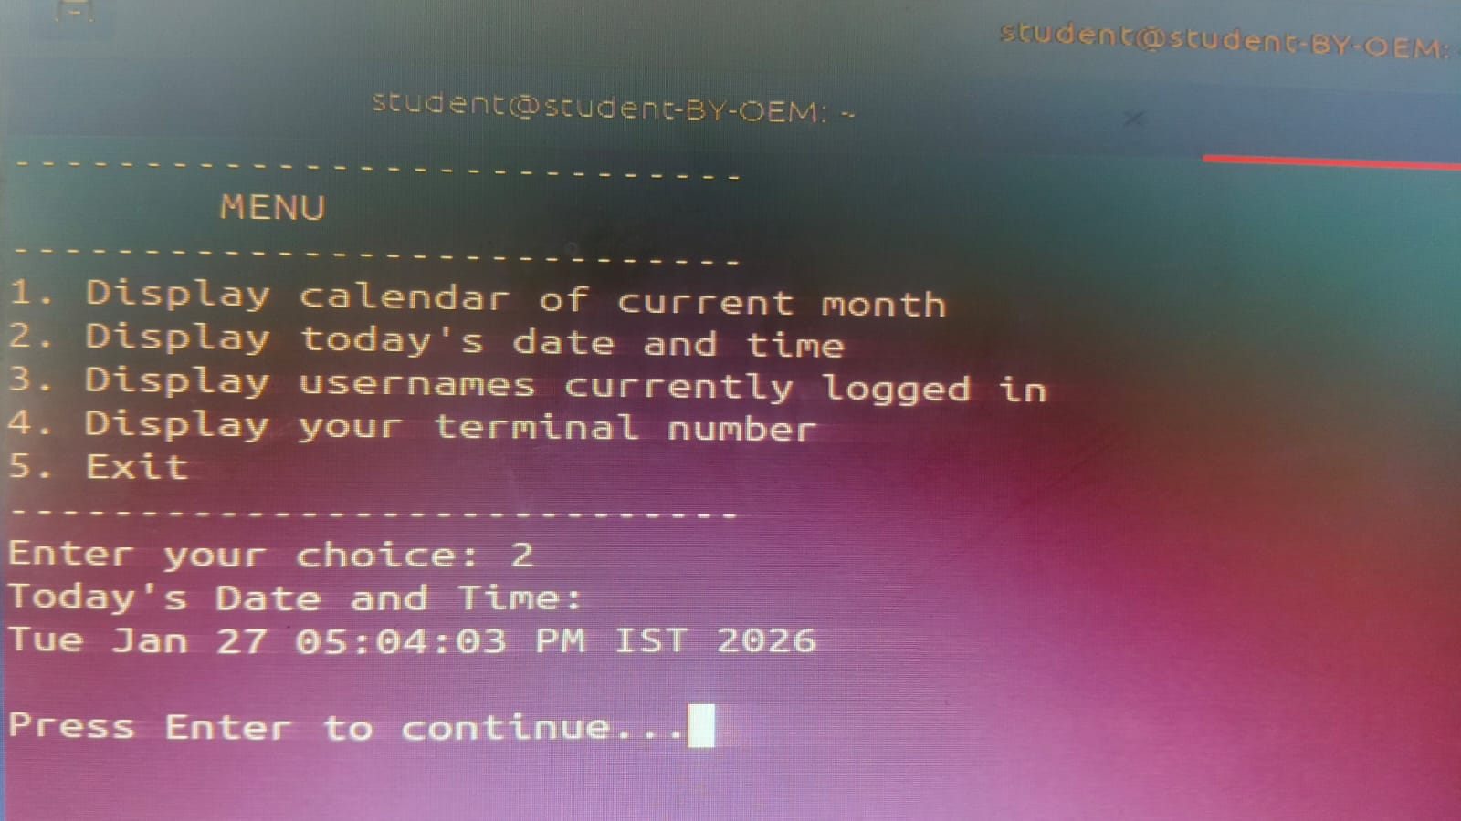
Output 2:
- W rite a shell script which will generate first n Fibonacci numbers like: 1, 1, 2, 3, 5, 13

Output 3:
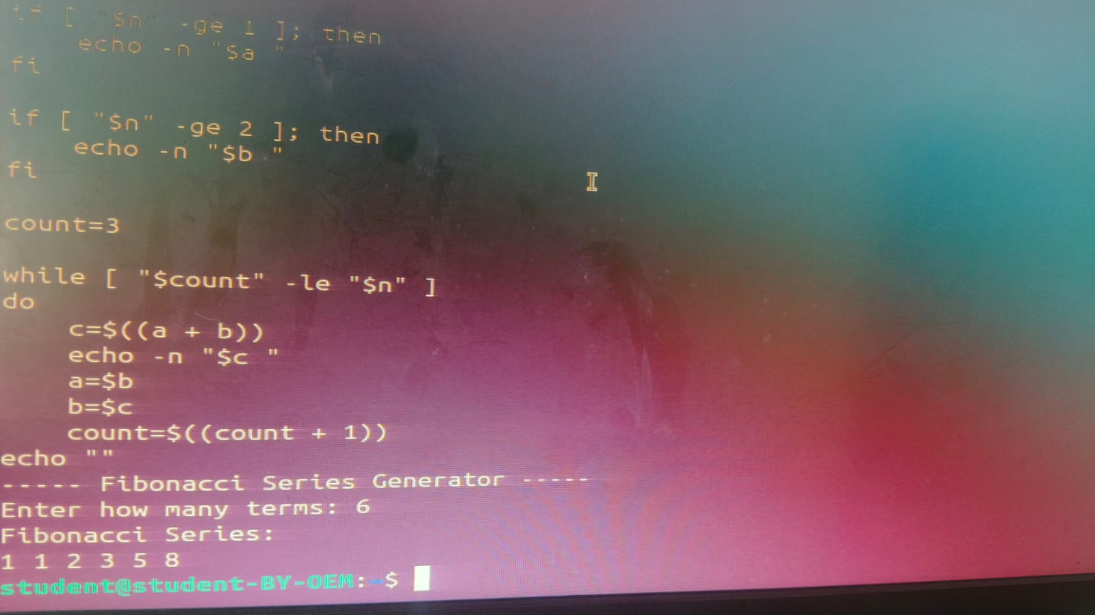
- Write a shell script which
will accept a number b and display first n prime numbers as output.

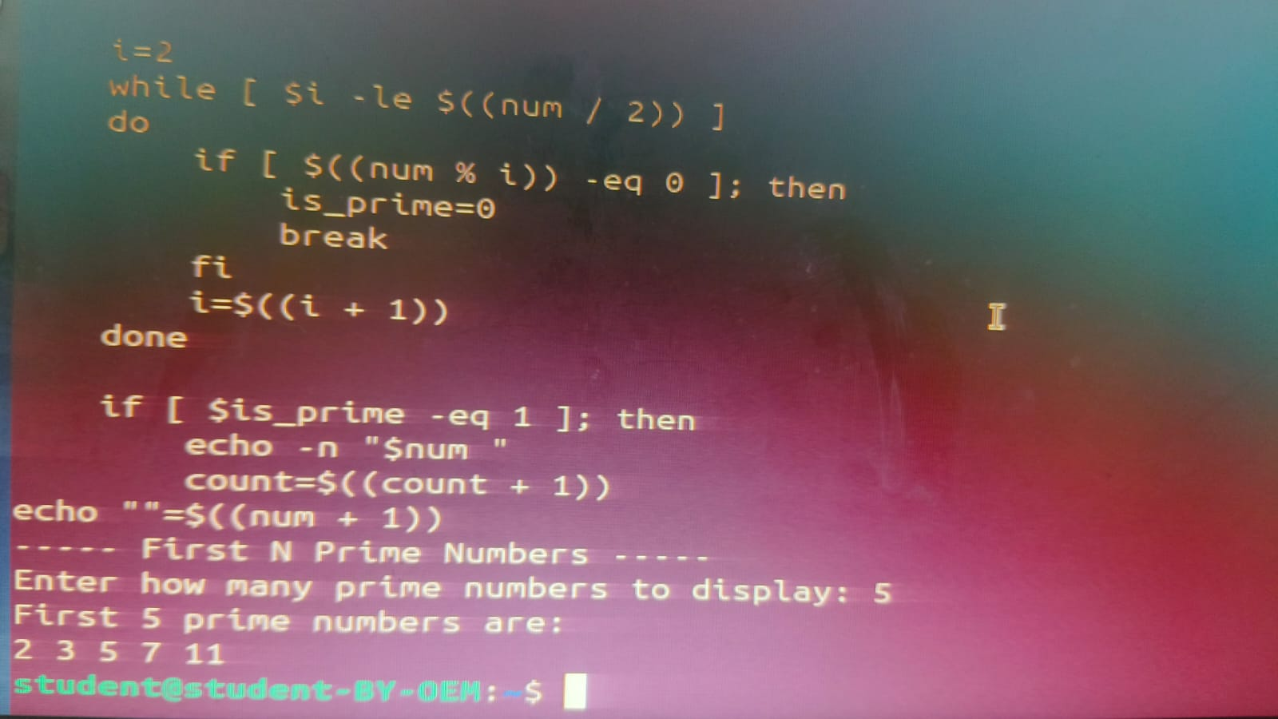
Output 4:

- Write menu driven program for file handling activity
  - Creation of file.
  - Write content in the file.
  - Upend file content.
  - Delete file content

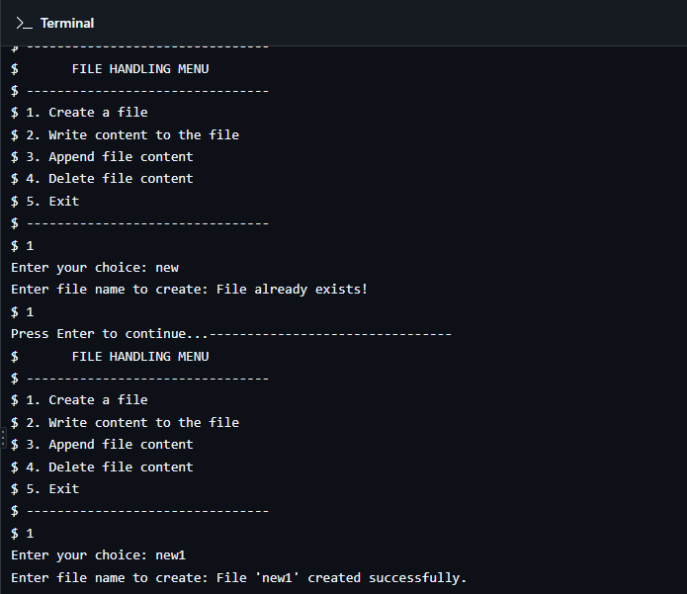
Output 5:

- Conclusion: In this practical, we conclude that shell scripting efficiently automates tasks like marksheet generation, system information display, number computations, and file management, enhancing system operations and user interaction through command-line utilities.

- Discussion Questions:
- What is the purpose of using shell scripting in this practical?
- Which command is used to display the current date and time?
- How does the script calculate the Fibonacci sequence?
- Which command is used to create a file in the file management script?
- How does the prime number script determine if a number is prime?

  - References: https://www.tutorialspoint.com/unix/shell_scripting.html https://www.javatpoint.com/shell-scripting-tutorial

Date: / /2026 Signature
Course Coordinator B.Tech CSE(AIML)

